Backend Project Progress Documentation (Till Now)
Successfully built the backend foundation of the deployment automation system.
Current architecture:
Client
↓
Express API
↓
MongoDB
↓
BullMQ Queue
↓
Redis
↓
Worker
The system now supports:
- Creating deployment requests
- Saving deployments to MongoDB
- Queueing deployment jobs asynchronously
- Processing jobs using BullMQ workers
- Updating deployment status lifecycle

APIs Built

1. Create Deployment
Endpoint
POST /api/deploy
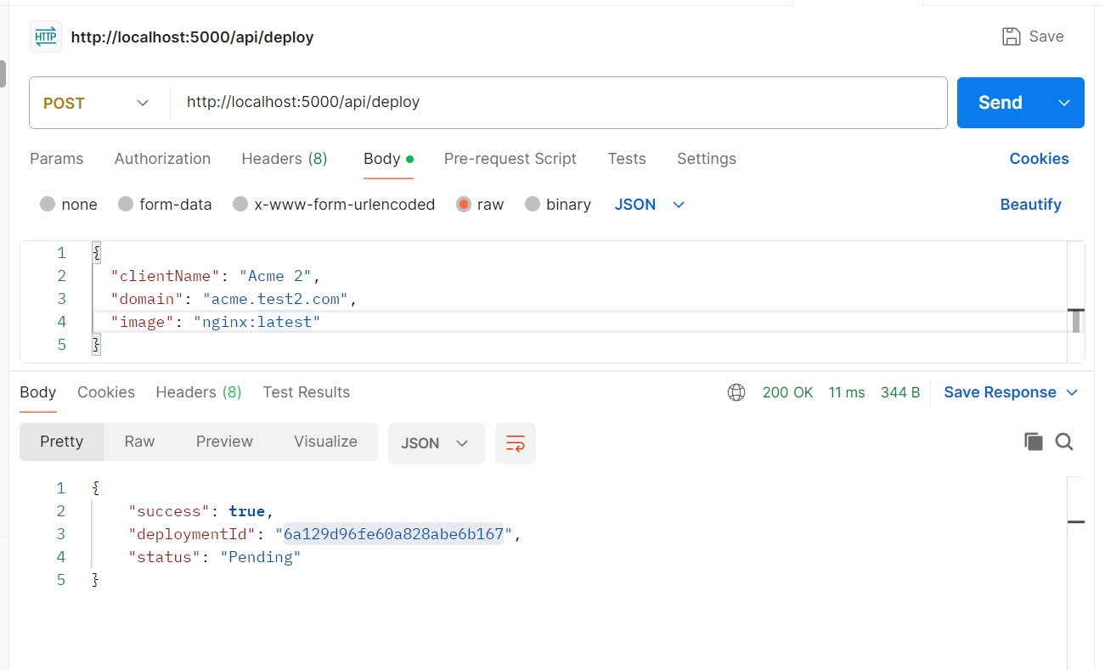
Purpose
- Accept deployment request
- Save deployment in MongoDB
- Add deployment job to BullMQ queue
- Return deployment ID immediately
Request Data
- clientName
- domain
- image
Initial Status
Pending

Flow
Client Request
↓
Save Deployment in MongoDB
↓
Add Job to BullMQ Queue
↓
Return Response Immediately

2. Get Deployment Status
Endpoint
GET /api/status/:id
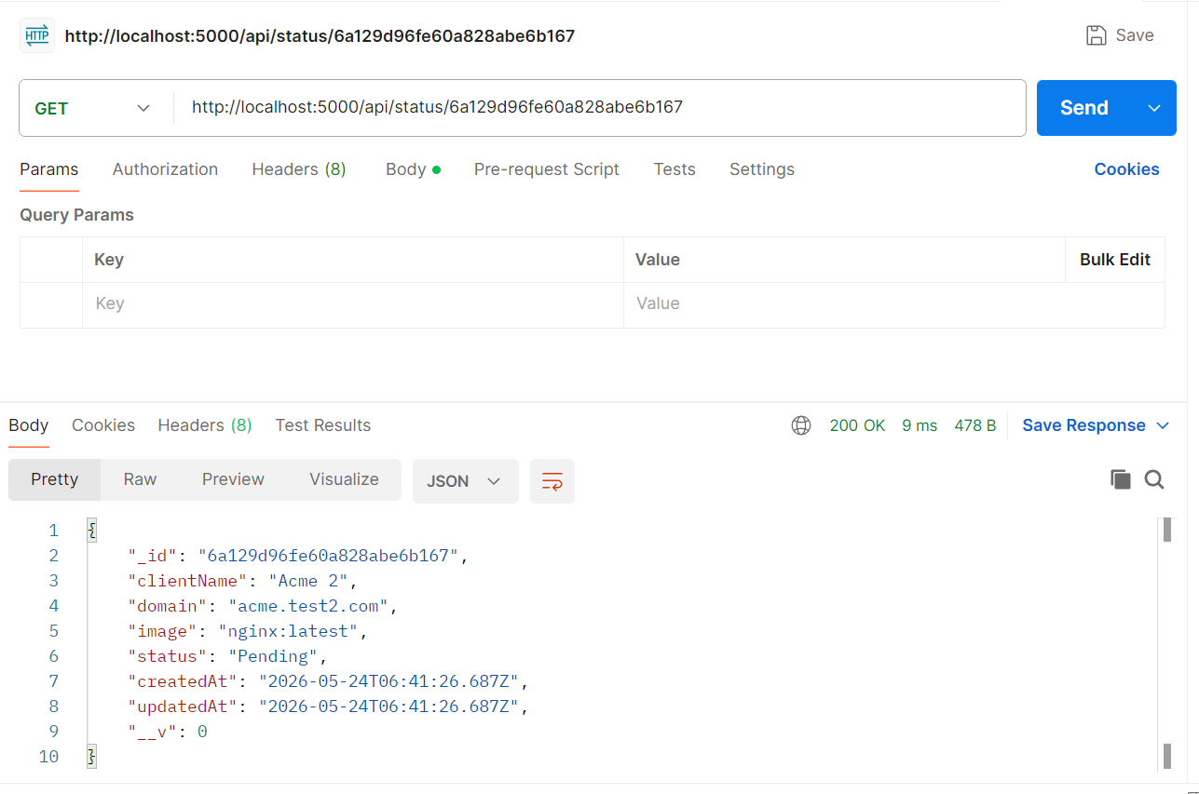
Purpose
- Fetch current deployment status
- Used for frontend polling/live updates
Possible Status Values
Pending
Running
Completed
Failed

Worker Flow
Worker Receives Queue Job
↓
Find Deployment in MongoDB
↓
Update Status → Running
↓
Process Deployment
↓
Update Status → Completed

Queue Flow
POST /api/deploy
↓
BullMQ Queue
↓
Redis
↓
Worker Processes Job

Technologies Used
Component | Technology
API Server | Express.js
Database | MongoDB
Queue | BullMQ
Queue Broker | Redis
Background Processing | Worker

Current System Capability
Async deployment processing
Background job execution
Deployment status tracking
Queue-based architecture
Real-time status readiness for frontend integration

PHASE 1 — Backend Project Setup

Step 1 — Create Backend Folder
Created:
server/

Step 2 — Initialize Node.js Project
Inside server/:
npm init -y

Step 3 — Install Backend Dependencies
Installed:
npm install express mongoose cors dotenv
Installed dev dependency:
npm install --save-dev nodemon

Step 4 — Update package.json
Updated scripts:
"scripts": {
"start": "node index.js",
"dev": "nodemon index.js"
}

PHASE 2 — Environment Setup

Step 5 — Create .env
Created:
server/.env
Added:
PORT=5000
MONGO_URI=mongodb://127.0.0.1:27017/deployments

PHASE 3 — MongoDB Integration

Step 6 — Create Deployment Schema
Created:
server/models/Deployment.js
Schema:
const mongoose = require("mongoose");

const deploymentSchema = new mongoose.Schema(
{
clientName: {
type: String,
required: true,
},

domain: {
type: String,
required: true,
},

image: {
type: String,
required: true,
},

status: {
type: String,
enum: ["Pending", "Running", "Completed", "Failed"],
default: "Pending",
},
},
{
timestamps: true,
}
);

module.exports = mongoose.model("Deployment", deploymentSchema);

PHASE 4 — Express Server Setup

Step 7 — Create Main Server
Created:
server/index.js
Responsibilities:
- Initialize Express
- Connect MongoDB
- Setup middleware
- Register routes

Express Middleware Used
app.use(cors());
app.use(express.json());

MongoDB Connection
mongoose.connect(process.env.MONGO_URI)

Server Started On
http://localhost:5000

PHASE 5 — Build REST APIs

Step 8 — Create Routes File
Created:
server/routes/deployRoutes.js

API 1 — Create Deployment
Endpoint
POST /api/deploy

Purpose
This API:
- Receives deployment form data
- Saves deployment in MongoDB
- Adds deployment job to BullMQ queue
- Returns deployment ID immediately

Request Body
{
"clientName": "Acme",
"domain": "acme.test.com",
"image": "nginx:latest"
}

Response
{
"success": true,
"deploymentId": "6a129c88fe60a828abe6b166",
"status": "Pending"
}

Internal Flow
Client Request
↓
Save MongoDB Record
↓
Add Queue Job
↓
Return Response

API 2 — Get Deployment Status
Endpoint
GET /api/status/:id

Purpose
Returns current deployment status.
Used by frontend polling/dashboard.

Example Request
GET /api/status/6a129c88fe60a828abe6b166

Example Response
{
"_id": "6a129c88fe60a828abe6b166",
"clientName": "Acme",
"domain": "acme.test.com",
"image": "nginx:latest",
"status": "Completed"
}

Added MongoDB ObjectId Validation
Used:
mongoose.Types.ObjectId.isValid(id)
to avoid invalid MongoDB ID crashes.

PHASE 6 — Redis + BullMQ Setup

Step 9 — Install Redis
Started Redis using Docker:
docker run -d --name redis -p 6379:6379 redis

Step 10 — Install Queue Packages
Inside server/:
npm install bullmq ioredis

Step 11 — Create Queue File
Created:
server/queue.js

Queue Setup
const { Queue } = require("bullmq");
const IORedis = require("ioredis");

const connection = new IORedis({
maxRetriesPerRequest: null,
});

const deploymentQueue = new Queue("deployments", {
connection,
});

module.exports = deploymentQueue;

Queue Name
deployments
This queue name is shared by:
- API producer
- Worker consumer

PHASE 7 — Queue Integration

Step 12 — Add Jobs To Queue
Inside:
POST /api/deploy
Added:
await deploymentQueue.add("deploy-job", {
deploymentId: deployment._id.toString(),
clientName,
domain,
image,
});

Updated Deployment Flow
POST /api/deploy
↓
Save MongoDB Record
↓
Add BullMQ Job
↓
Return Response Immediately

PHASE 8 — Worker Setup

Step 13 — Create Worker Folder
Created:
worker/

Step 14 — Initialize Worker Project
Inside worker/:
npm init -y

Step 15 — Install Worker Dependencies
Installed:
npm install bullmq ioredis mongoose dotenv

Step 16 — Create Worker Environment File
Created:
worker/.env
Added:
MONGO_URI=mongodb://127.0.0.1:27017/deployments

Step 17 — Create Worker
Created:
worker/index.js

Worker Responsibilities
The worker:
- Consumes BullMQ jobs
- Reads deployment data
- Updates deployment status
- Simulates deployment process
- Marks deployment completed

Worker Queue Consumer
new Worker("deployments", ...)

Worker Job Lifecycle
Receive Job
↓
Find Deployment
↓
Update Status → Running
↓
Simulate Deployment
↓
Update Status → Completed

Fake Deployment Simulation
Used:
setTimeout()
temporarily to simulate deployment processing.

PHASE 9 — Full System Execution

Backend Server
Started using:
npm run dev

Worker
Started using:
node index.js

Redis Verification
Verified using:
docker ps

Full Working Flow
Current complete flow:
POST /api/deploy
↓
MongoDB Save
↓
BullMQ Queue
↓
Redis
↓
Worker Receives Job
↓
Status = Running
↓
Status = Completed

Current Status Lifecycle
Deployment status transitions:
Pending
↓
Running
↓
Completed
Possible failure state:
Failed

Technologies Used
Layer | Technology
Backend API | Express.js
Database | MongoDB + Mongoose
Queue | BullMQ
Queue Broker | Redis
Worker | Node.js
Environment | dotenv
Dev Tooling | Nodemon
Container Runtime | Docker (Redis container)

What Is Fully Working Now
✅ Express backend
✅ MongoDB integration
✅ REST APIs
✅ Deployment schema
✅ BullMQ producer
✅ Redis queue broker
✅ Worker consumer
✅ Background processing
✅ Deployment status lifecycle
✅ Async architecture

Current Architecture
Client
↓
Express API
↓
MongoDB
↓
BullMQ Queue
↓
Redis
↓
Worker

NEXT PHASE
Next implementation phase:
Worker
↓
SSH Into EC2
↓
Docker Commands
↓
Container Deployment
↓
AWS Lambda Invocation
Upcoming tasks:
- SSH into EC2
- Execute remote Docker commands
- Pull Docker images dynamically
- Run containers dynamically
- Trigger AWS Lambda
- Build React frontend
- Add live polling dashboard

